Project Title: Wearable Robot Puppet with Eye-Blinking and Tracking using Computer Vision

Proposer: Self (in collaboration with an Arts University Plymouth Final Year Student)

Supervisor: Dena Bazazian

Objective:
- The main objective of this project is to design and develop an animatronic head for the Arts University students’ wearable puppet, inspired by a dragon-like creature.
- The ultimate goal is to bring their puppet to life through realistic moveable eyeballs and eyelids and a moveable beak which opens and closes using servos for actuation and computer vision for person-detection and tracking. The final design would be as one complete structure allowing ease for the student to place within their puppet.

Staged Deliverables (at least 4):
PASS (40%+):
To achieve a functioning physical prototype of the eyes, beak and eye covering and simulation of its expected movement. This includes:
- Fusion 360 CAD modelling and technical drawings of the eyes, beak, servo mounts, battery and microcontroller housings, and eye covering plate.
- Incorporating camera placement in the pupil/ above eye.
- Fusion 360 animating to simulate expected movement (blink, move eyeball, open and close beak).
- 3D-printing parts with iterative design documentation.
- Fitment check with artist’s puppet structure.
2:2 Mark (50%+)
To achieve mechanical actuation of motion. This includes:
- Calibrating servos.
- Servo mapping and forward kinematics.
- Programming servo movement to make:
  - Eyes blink (1DOF)
  - Eyeballs move (2DOF)
  - Beak open and close (1DOF)
- Controlling the movement on ESP32 microcontrollers and PWM drivers.
- Creating a standard looped movement sequence for the eyes and beak. This is intended to be used in more crowded environments.

2:1 Mark (60%+)
To achieve person-detection with the vision system. This includes:
- Operating the ESP32-CAM modules.
- Person-detection using computer vision.
- Testing across different lighting.
- Sending data to ESP32 board.

FIRST CLASS Mark (70%+)
To achieve full integration of both the mechanical and vision system. This includes:
- Mapping camera data to servo movements to allow eye tracking of people.
- Independent tracking for each eye (since they sit on opposite sides of the head).
- Additional enhancements such as synchronized sound with beak motion or refined eye movement mimicking the expression of the person being tracked.
- Professional finish and detailed documentation of design process and testing.
- Have the option of controlling the eyes via joystick.

Description:
This project aims to combine robotics, art, and performance by creating a wearable robotic puppet head that responds dynamically to people. The system will feature realistic eye blinking, motion tracking, and beak articulation, controlled through small servos and ESP32 microcontroller.
Initially, CAD software (Fusion 360) will be used to design the eye and beak mechanisms. After simulation and refinement, parts will be 3D printed with PLA and assembled with servo mounts and control boards using various nuts and bolts. These will also undergo further refinement after fit checks.
The eyeballs themselves will move in 2DOF (up and down and left and right) and the eye lids which open and close (1 DOF). These would be actuated using 4 9g micro servos per eye. Each eye will be able to move independently. Their movement would be controlled using the PCA9685 PWM driver and ESP32 board.
It is intended that eyeball module is separate from one another, meaning each eye will have a dedicated ESP32, ESP32CAM, PWM driver, 4 servos and its own battery supply. The battery will potentially be a 6V battery pack but depending on the amount of current taken by the servos through testing, other means such as a Lipo and buck converter can be used.
The beak will also be actuated using one servo to open and close it, but this will potentially need a heavier MG996R servo for actuation. If the lighter micro servo will suffice, then that will be used instead.
The ESP32-CAM modules will enable person detection. The camera will be placed in the eyeball pupil or above the eyeball. The ESP32-CAM will send data to the ESP32, which will then send the mappings to the PWM driver, allowing the puppet’s eyes to follow a person’s movement.
All code will be developed in Arduino IDE, and iterative testing will be conducted. The final system will be designed for easy integration into an artist’s wearable puppet, allowing them to animate their creature during live performance.
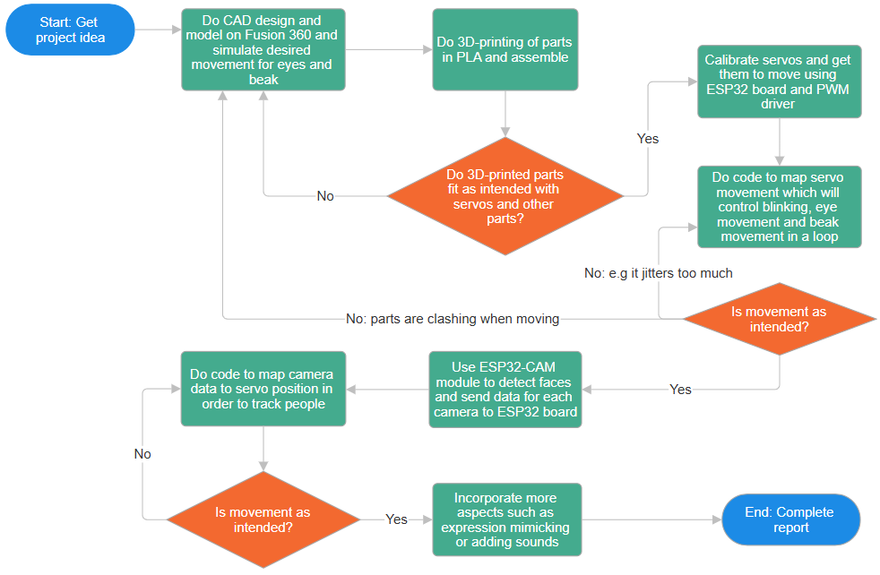
Figure 1: Flowchart Diagram of Project

Resources
- State assumptions about resources allocated to this project: Assume resources can be purchased within budget of £120.00
- Equipment: Power supply for testing, Laptop for CAD, 3D-printer for parts
- Locations: Lab
- Support & outside services: Lab techs
- Manufacturing: Not required

Schedule
- Deliverable 1 (Design and Simulation): By start of February (09/02/26)
- Deliverable 2 (Servo Actuation and Coding): By end of February (25/02/26)
- Progress Demonstration: February 26th, 2026
- Deliverable 3 (Vision System Integration): By middle of March (16/03/26)
- Deliverable 4 (Full Integration and Testing): By middle of April (13/04/26)

Related Documents
- Data Sheets:
- 9G Micro Servos
- Web Pages: More to be included as research continues
- Building a Robot that Sees (Through its Own Eyes): https://www.youtube.com/watch?v=IPBu5Q2aogE
- Plymouth Owl:
https://www.plymouth.ac.uk/research/robotics-neural-systems/plymouth-owl

